**ps – Displays the currently active processes**

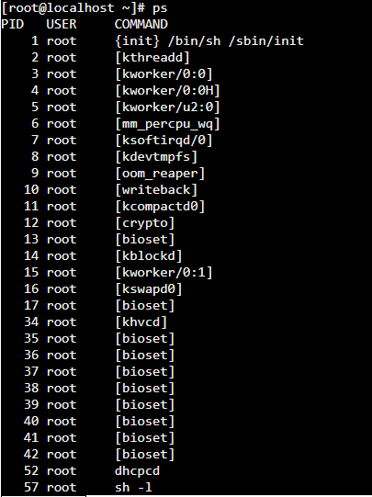

2) top – displays the running processes



3) kill – To kill the PID/ process that I hung



4) date – To display the current date



5) cal – To display the current month

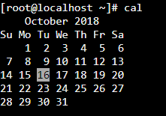

6) uptime – To know the system running/ up time



7) whoami – whom you are logged in as



8) uname –a – shows the kernel information



9) cat /proc/cpuinfo – To display the cpu information

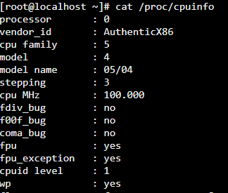

10) cat /proc/meminfo – To display the memory information

